|  |
| --- |
|  |
| Capstone Project Document |

**Vietnam Medicinal plants Network**

Report #2 – Data Design

|  |  |  |
| --- | --- | --- |
| **Dandelion** | | |
| **Group Members** | Trần Bình Khánh | SE02764 |
| Nguyễn Minh Tiến | SE02545 |
| Nguyễn Hải Đăng | SE02992 |
| Hoàng Thị Quỳnh | SE02639 |
| **Supervisor** | Mr. Nguyễn Văn Sang | |
| **Project code** | VMN | |

**- Hanoi, 03/2016 –**

# SIGNATURE PAGE

AUTHOR: Trần Bình Khánh 26/09/2015

Team member

REVIEWERS: Nguyễn Minh Tiến 27/09/2015

Project manager

APPROVAL: Nguyễn Văn Sang --/--/--15

Supervisor

Record of change

*A - Added M - Modified D – Deleted

|  |  |  |  |  |  |
| --- | --- | --- | --- | --- | --- |
| Effective Date | Changed Item | A,M,D | Change Description | Reason for Change | Rev. Number |
| 26/Sep/2015 | Create Data Design | A | Create Data Design | First version | 1.0 |
|  |  |  |  |  |  |
|  |  |  |  |  |  |
|  |  |  |  |  |  |
|  |  |  |  |  |  |
|  |  |  |  |  |  |
|  |  |  |  |  |  |
|  |  |  |  |  |  |
|  |  |  |  |  |  |
|  |  |  |  |  |  |
|  |  |  |  |  |  |
|  |  |  |  |  |  |
|  |  |  |  |  |  |
|  |  |  |  |  |  |
|  |  |  |  |  |  |
|  |  |  |  |  |  |
|  |  |  |  |  |  |
|  |  |  |  |  |  |
|  |  |  |  |  |  |
|  |  |  |  |  |  |
|  |  |  |  |  |  |
|  |  |  |  |  |  |
|  |  |  |  |  |  |
|  |  |  |  |  |  |

Table Contents

SIGNATURE PAGE 0

1 INTRODUCTION 3

1.1 Purpose 3

1.2 Acronyms and Definitions 3

1.3 References 3

1.4 Overview 3

2 Database 4

2.1 Entity Relationship Diagram 4

2.1.1 Entity description 5

2.1.2 Relationship 5

2.2 Table Diagram 7

2.2.1 Credential table 7

2.2.2 Password_resets table 8

2.2.3 Medicinal_plants table 8

2.2.4 Remedies table 9

2.2.5 Remedy_ingredients table 9

2.2.6 Members table 10

2.2.7 Medicinal_plants_history table 10

2.2.8 Medicinal_plants_reviews table 11

2.2.9 medicinal_plants_reports table 12

2.2.10 Remedies_history table 12

2.2.11 Remedies_reviews table 13

2.2.12 Remedies_reports table 13

2.2.13 Herbal_medicine_stores table 14

# INTRODUCTION

## Purpose

Fly Away Plus data design document describes structure of database and file structure of system including internal file structure as well as interface file structure.

## Acronyms and Definitions

|  |  |
| --- | --- |
| **Acronym & Abbreviation** | **Definition** |
| VMN | Vietnam Medicinal Plants Network |
| FU | FPT University |
| Q&A | Question and Answer |

Table 1‑1: Acronyms and Definitions

## References

|  |  |
| --- | --- |
| **Document** | **Title** |
| Class Design Document | VMN_Class Design_v1.0_EN |
| Architecture Design | VMN_Architecture Design_v1.0_EN |
| Software Requirement Specification | VMN_Software Requirement Specification_v1.0_EN |

Table 1‑2: References

## Overview

This document describes relationship between entities and properties of each entity.

# Database

## Entity Relationship Diagram

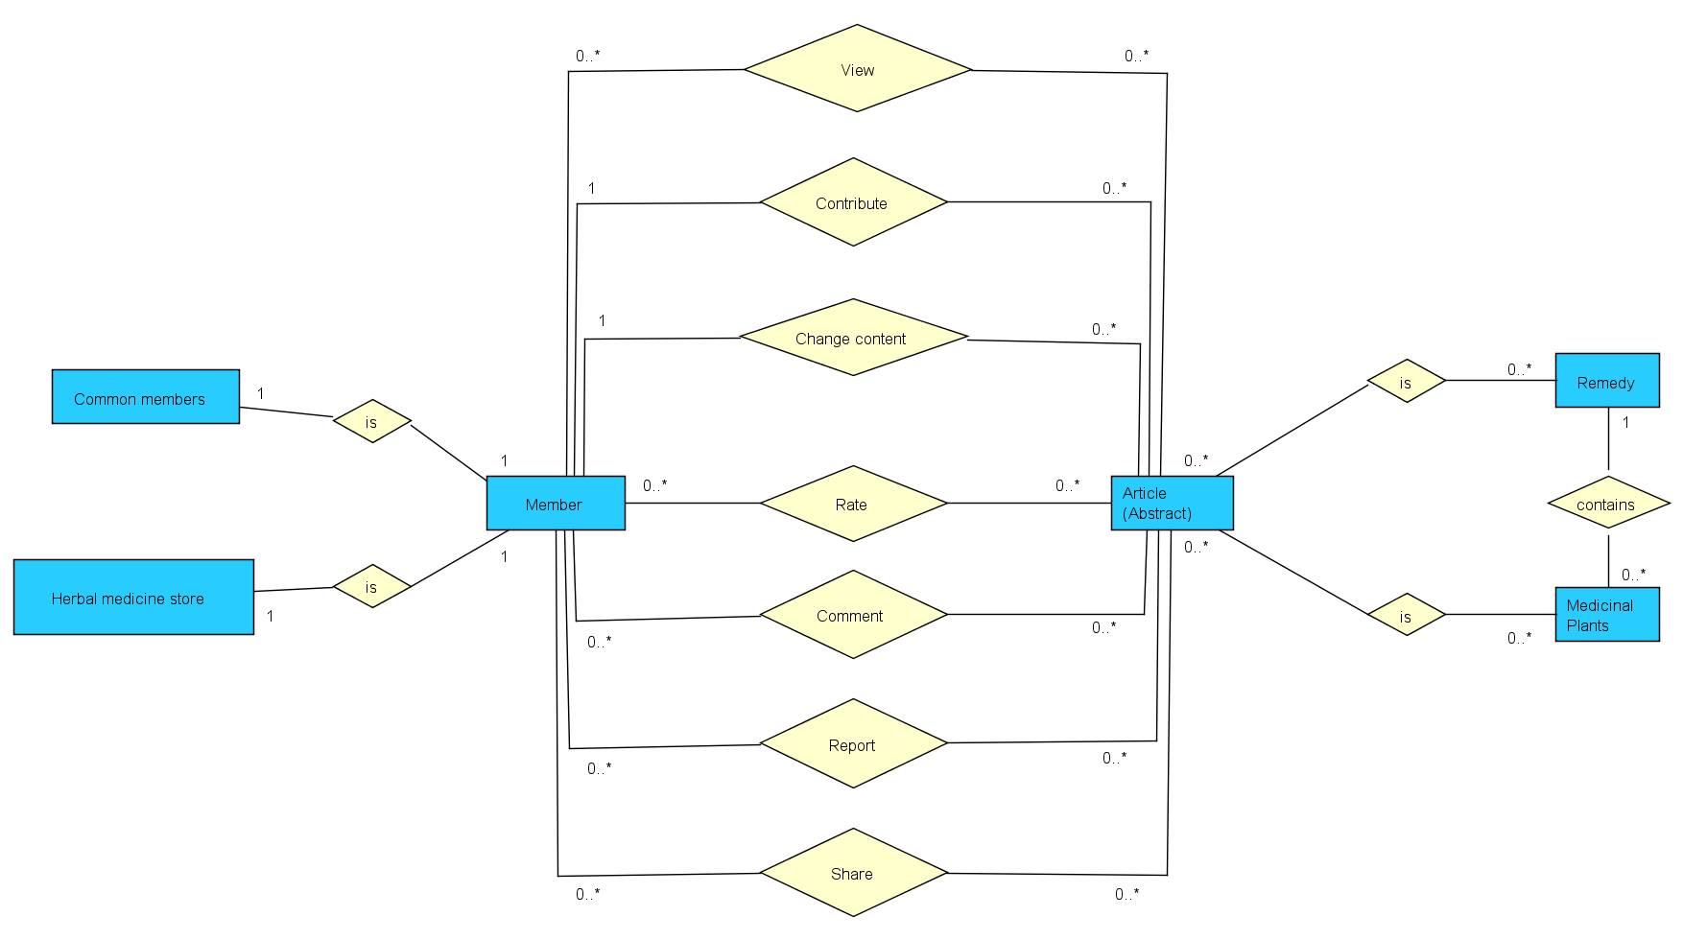

**Figure 2‑1:** Entity Relationship Diagram

### Entity description

|  |  |  |
| --- | --- | --- |
| **No** | **Entity** | **Description** |
|  | Member | User is all people who using VMN feature |
|  | Article | A Article which user created, includes content, photo to describe the medicinal plants/remedy. |
|  | Common members | User is not herbal medicine store |
|  | Herbal medicine store | User(special) can register to show all store’s information (Remedy/medicinal plants/location/contact) |
|  | Remedy | A article describe the remedy |
|  | Medicinal plants | A article describe the medicinal plants |

**Table 2-3:** Entity description

### Relationship

|  |  |  |  |  |  |
| --- | --- | --- | --- | --- | --- |
| **No** | **Relation** | **Properties** | **From** | **To** | **Description** |
|  | CONTAINS | None | Remedy | Medicinal plants | A remedy contains many medicinal plants |
|  | HAS | None | Remedy | Update | A update of article which was changed by creator |
|  | HAS | None | Medicinal plants | Update | A update of article which was changed by creator |
|  | IS | None | Members | Common members | A member is a Common members |
|  | IS | None | Members | Herbal medicine store | A member is a Herbal medicine store |
|  | IS | None | Article | Remedy | A article is a Remedy |
|  | IS | None | Article | Medicinal plants | A article is a Medicinal plants |
|  | COMMENT | MemberID  ArticleID | Members | Article | A Comment which user give to article |
|  | BASIC SEARCH | MemberID  ArticleID | Members | Article | A article which user searching article |
|  | ADVANCE SEARCH | MemberID  ArticleID | Members | Article | A article which user advance searching article |
|  | REPORT | MemberID  ArticleID | Members | Article | A Report which user report a project |
|  | CONTRIBUTE | None | Members | Article | A Contribute which user contributed article |
|  | REPORT | MemberID  ArticleID | Members | Article | A Report which User report article |
|  | CHANGE | MemberID  ArticleID | Members | Article | A Change which user changed a article |
|  | RATE | MemberID  ArticleID | Members | Article | A Rate which user rating a article |
|  | SHARE | MemberID  ArticleID | Members | Article | A Share which User share article |

Table 2‑1: Relationship description

## Table Diagram

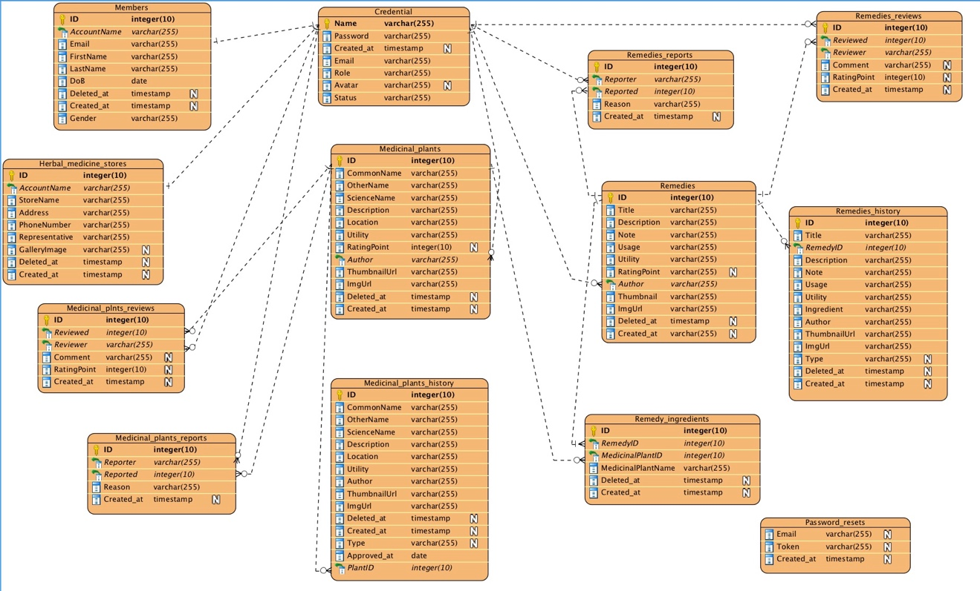

**Figure 2‑2:** Table Diagram

### Credential table

|  |  |  |  |  |
| --- | --- | --- | --- | --- |
| **No** | **Field Name** | **Type** | **Allow Null** | **Description** |
|  | Name | String | No | User’s name |
|  | Password | String | No | User’s password |
|  | RememberToken | String |  | An unique string that is generated by login action |
|  | Created_at | Timestamps |  | The time that account was created |
|  | Email | String | No | User’s email |
|  | Role | String | No | Member’s role |
|  | Avatar | String |  | Link to avatar |
|  | Status | String | No | Member’s status |

Table 2‑2: Credential table

### Password_resets table

|  |  |  |  |  |
| --- | --- | --- | --- | --- |
| **No** | **Field Name** | **Type** | **Allow Null** | **Description** |
|  | Email | String | No | Member’s email |
|  | Token | String |  | An unique string that is generated by login action |
|  | Created_at | Timestamp |  | The time that account was created |

Table 2‑2: Password_resets table

### Medicinal_plants table

|  |  |  |  |  |
| --- | --- | --- | --- | --- |
| **No** | **Field Name** | **Type** | **Allow Null** | **Description** |
|  | ID | int | No | Medicinal plant’s ID |
|  | CommonName | String | No | Medicinal plant’s Common Name |
|  | OtherName | String | No | Medicinal plant’s Other Name |
|  | ScienceName | String | No | Medicinal plant’s Science Name |
|  | Description | String | No | Medicinal plant’s Description |
|  | Location | String | No | Medicinal plant’s Location |
|  | Utility | String | No | Medicinal plant’s Utility |
|  | RatingPoint | Int |  | Medicinal plant’s RatingPoint |
|  | Author | String | No | Medicinal plant’s Author |
|  | ThumbnaiUrl | Text | No | Link to thumbnail image |
|  | ImgUrl | Text | No | Links to medicinal plant’s image |
|  | Deleted_at | Timestamps |  | The time that medicinal plant was deleted |
|  | Created_at | Timestamps |  | The time that medicinal plant was created |

Table 2‑3: Medicinal_plants table

### Remedies table

|  |  |  |  |  |
| --- | --- | --- | --- | --- |
| **No** | **Field Name** | **Type** | **Allow Null** | **Description** |
|  | ID | Int | No | Remedy’s ID |
|  | Title | String | No | Remedy’s Title |
|  | Description | String | No | Remedy’s Description |
|  | Note | String | No | Remedy’s Note |
|  | Usage | String | No | Remedy’s Usage |
|  | Utility | String | No | Remedy’s Utility |
|  | RatingPoint | Int |  | Remedy’s RatingPoint |
|  | Author | String | No | Remedy’s Author |
|  | ThumbnailUrl | Text | No | Link to thumbnail image |
|  | ImgUrl | Text | No | Links to remedy’s image |
|  | Deleted_at | Timestamps |  | The time that remedy was deleted |
|  | Created_at | Timestamps |  | The time that remedy was created |

Table 2‑4: Remedies table

### Remedy_ingredients table

|  |  |  |  |  |
| --- | --- | --- | --- | --- |
| **No** | **Field Name** | **Type** | **Allow Null** | **Description** |
|  | ID | Int | No | Primary key of table |
|  | RemedyID | Int | No | Remedy’s ID |
|  | MedicinalPlantID | Int | No | Medicinal plant’s ID |
|  | MedicinalPlantName | String | No | Medicinal plant’s Name |
|  | Dosage |  |  |  |
|  | Deleted_at | Timestamps |  | The time that record was deleted |
|  | Created_at | Timestamps |  | The time that record was created |

Table 2‑5: Remedy_ingredients table

### Members table

|  |  |  |  |  |
| --- | --- | --- | --- | --- |
| **No** | **Field Name** | **Type** | **Allow Null** | **Description** |
|  | ID | INT | No | Member’s ID |
|  | AccountName | String | No | Member’s Account Name |
|  | Email | String | No | Member’s Email |
|  | FirstName | String | No | Member’s First Name |
|  | LastName | String | No | Member’s Last Name |
|  | DoB | Date | No | Member’s Date Of Birth |
|  | Deleted_at | Timestamps |  | The time that account was deleted |
|  | Created_at | Timestamps |  | The time that account was created |
|  | Gender | String | No | Member’s Gender |

Table 2‑6: Members table

### Medicinal_plants_history table

|  |  |  |  |  |
| --- | --- | --- | --- | --- |
| **No** | **Field Name** | **Type** | **Allow Null** | **Description** |
|  | ID | int | No | Primary key of table |
|  | CommonName | String | No | Medicinal plant’s CommonName |
|  | OtherName | String | No | Medicinal plant’s Other Name |
|  | ScienceName | String | No | Medicinal plant’s Science Name |
|  | Description | String | No | Medicinal plant’s Characteristic |
|  | Location | String | No | Medicinal plant’s Location |
|  | Utility | String | No | Medicinal plant’s Utility |
|  | Author | String | No | Medicinal plant’s Author |
|  | ThumbnailUrl | Text | No | Link to thumbnail image |
|  | ImgUrl | Text | No | Links to Medicinal plant’s image |
|  | Deleted_at | Timestamps |  | The time that log was deleted |
|  | Created_at | Timestamps |  | The time that log was created |
|  | Type | String |  | Type of log (add or edit) |
|  | Approved_at | DateTime | No | The time that log was approved |
|  | PlantId | String | No | Medicinal plant’s ID (for type = edit) |

Table 2‑8: Medicinal_plants_history table

### Medicinal_plants_reviews table

|  |  |  |  |  |
| --- | --- | --- | --- | --- |
| **No** | **Field Name** | **Type** | **Allow Null** | **Description** |
|  | ID | Int | No | Primary key of table |
|  | Reviewed | Int | No | Medicinal plant’s Reviewed from Member |
|  | Reviewer | String | No | Medicinal plant’s Reviewer |
|  | Comment | LongText |  | Medicinal plant’s Comment from Member |
|  | RatingPoint | Int |  | Medicinal plant’s Rating point from Member |
|  | Created_at | Timestamps |  | The time that log was created |

Table 2‑9: Medicinal_plants_reviews table

### medicinal_plants_reports table

|  |  |  |  |  |
| --- | --- | --- | --- | --- |
| **No** | **Field Name** | **Type** | **Allow Null** | **Description** |
|  | ID | Int | No | Primary key of table |
|  | Reporter | String | No | Medicinal plant’s Reporter |
|  | Reported | Int | No | Medicinal plant’s Reported from Member |
|  | Reason | LongText | No | Medicinal plant’s Reason from Member |
|  | Created_at | Timestamps |  | The time that log was created |

Table 2‑10: Medicinal_plants_reports table

### Remedies_history table

|  |  |  |  |  |
| --- | --- | --- | --- | --- |
| **No** | **Field Name** | **Type** | **Allow Null** | **Description** |
|  | ID | int | No | Primary key of table |
|  | Title | String | No | Remedy’s Title |
|  | remedyId | Int | No | Remedy’s ID |
|  | Description | String | No | Remedy’s Description |
|  | Note | String | No | Remedy’s Note |
|  | Usage | String | No | Remedy’s Usage |
|  | Utility | String | No | Remedy’s Utility |
|  | Ingredient | String | No | Medicinal plants that is contained in this remedy |
|  | Author | String | No | Remedy’s Author |
|  | ThumbnailUrl | Text | No | Link to thumbnail image |
|  | ImgUrl | Text | No | Links to remedy’s image |
|  | Type | String |  | Type of log (add or edit) |
|  | Deleted_at | Timestamps |  | The time that log was deleted |
|  | Created_at | Timestamps |  | The time that log was created |

Table 2‑11: Remedies_history table

### Remedies_reviews table

|  |  |  |  |  |
| --- | --- | --- | --- | --- |
| **No** | **Field Name** | **Type** | **Allow Null** | **Description** |
|  | ID | Int | No | Primary key of table |
|  | Reviewed | Int | No | Remedy’s Reviewed from Member |
|  | Reviewer | String | No | Remedy’s Reviewer |
|  | Comment | LongText |  | Remedy’s Comment from Member |
|  | RatingPoint | Int |  | Remedy’s Rating point from Member |
|  | Created_at | Timestamps |  | The time that log was created |

Table 2‑12: Remedies_reviews table

### Remedies_reports table

|  |  |  |  |  |
| --- | --- | --- | --- | --- |
| **No** | **Field Name** | **Type** | **Allow Null** | **Description** |
|  | ID | int | No | Primary key of table |
|  | Reporter | String | No | Remedy’s Reporter |
|  | Reported | Int | No | Remedy’s Reported from Member |
|  | Reason | LongText | No | Remedy’s Reason from Member |
|  | Created_at | Timestamps |  | The time that log was created |

Table 2‑13: Remedies_reports table

### Herbal_medicine_stores table

|  |  |  |  |  |
| --- | --- | --- | --- | --- |
| **No** | **Field Name** | **Type** | **Allow Null** | **Description** |
|  | ID | int | No | Herbal medicine store’s ID |
|  | AccountName | String | No | Herbal medicine store’s Account Name |
|  | StoreName | String | No | Herbal medicine store’s Name |
|  | Address | String | No | Herbal medicine store’s Address |
|  | Phonenumber | String | No | Herbal medicine store’s Phone number |
|  | Representative | String | No | Herbal medicine store’s Representative |
|  | GalleryImage | String |  | Herbal medicine store’s Image |
|  | Deleted_at | timestamps |  | The time that Herbal medicine store was deleted |
|  | Created_at | timestamps |  | The time that Herbal medicine store was created |

Table 2‑14: Herbal_medicine_stores table